**API document**

**Set up using Maven**

**- mvn compile**

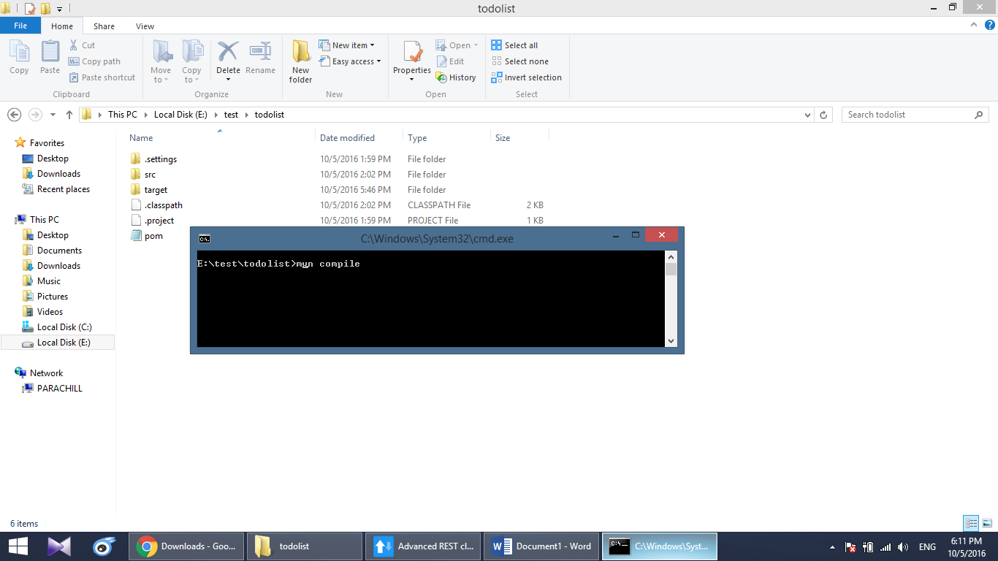

**- mvn spring-boot:run**

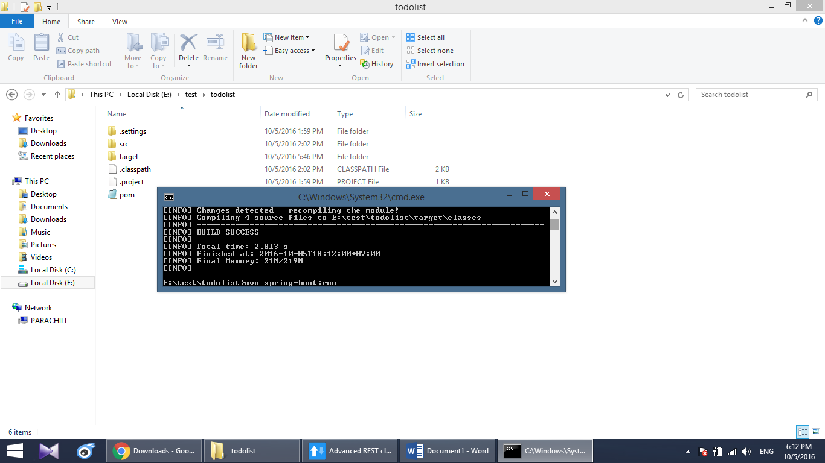

**- Service start**

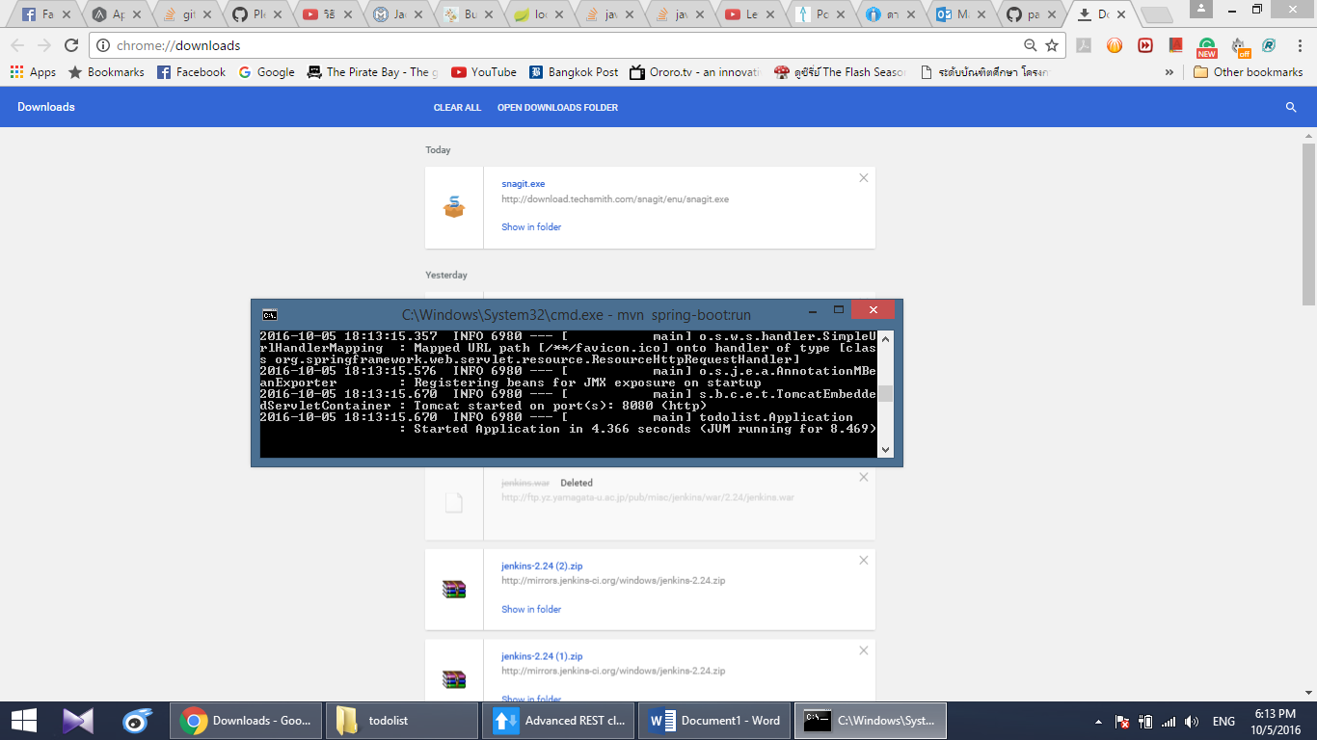

# View all items

URL:[**http://localhost:8080/todo/**](http://localhost:8080/todo/)

View all tasks

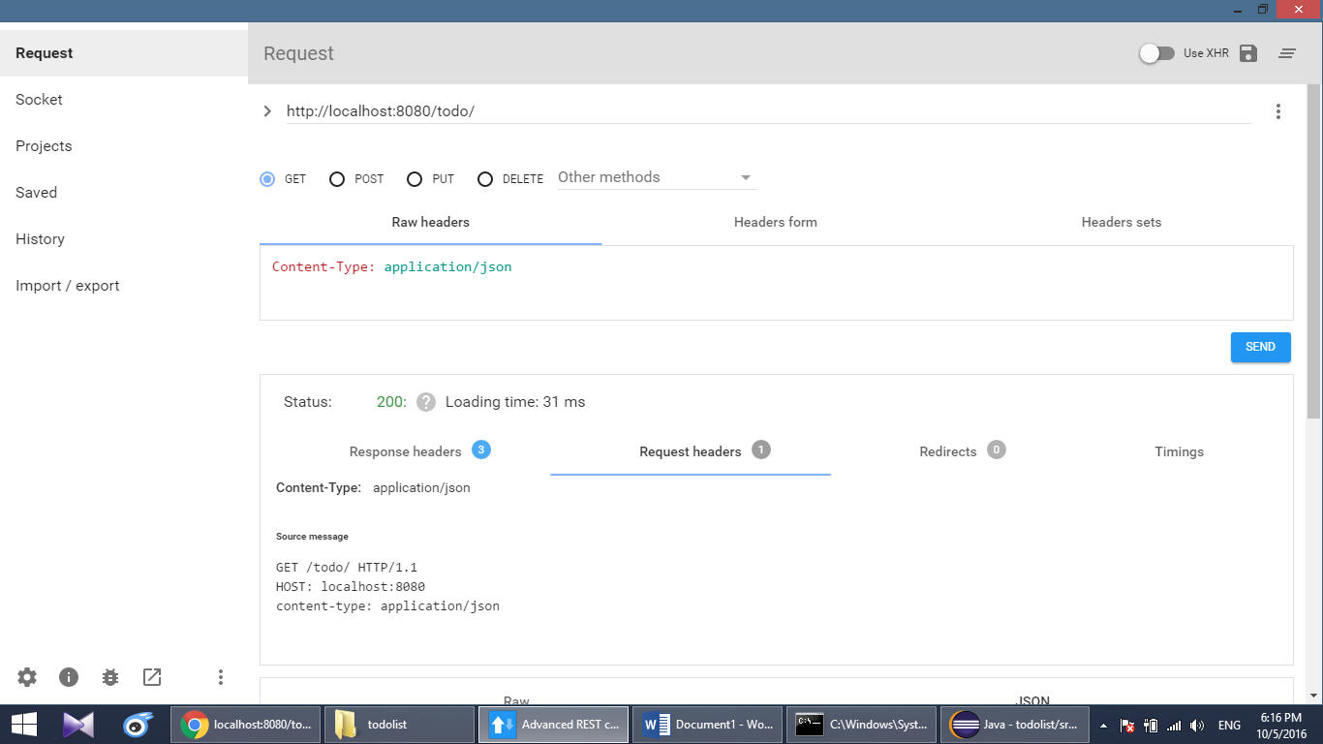

**Result**

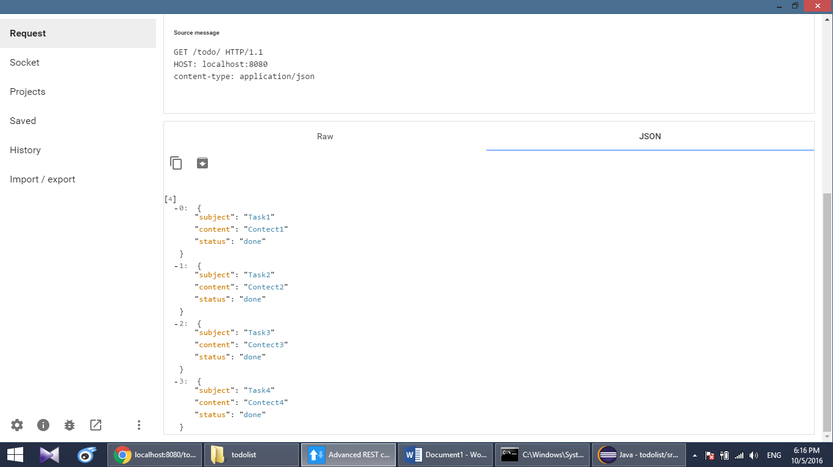

# View a task

URL:[**http://localhost:8080/todo/{tasksubject}**](http://localhost:8080/todo/%7btasksubject%7d)

View Task1

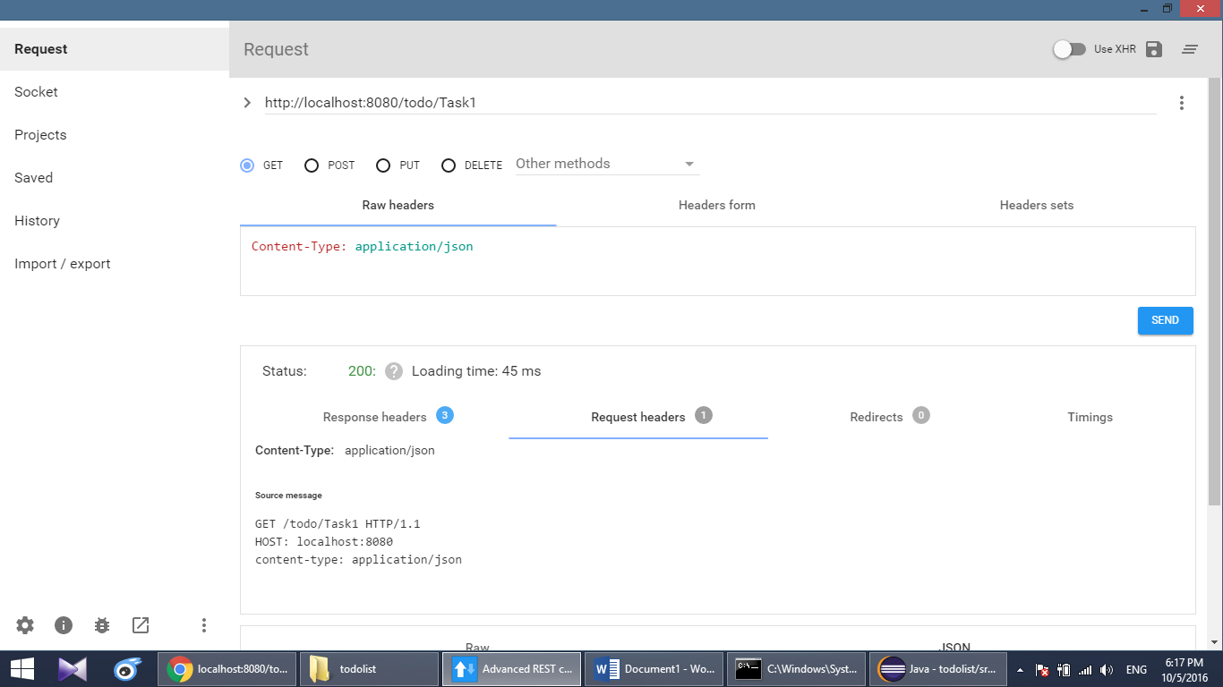

**Result**

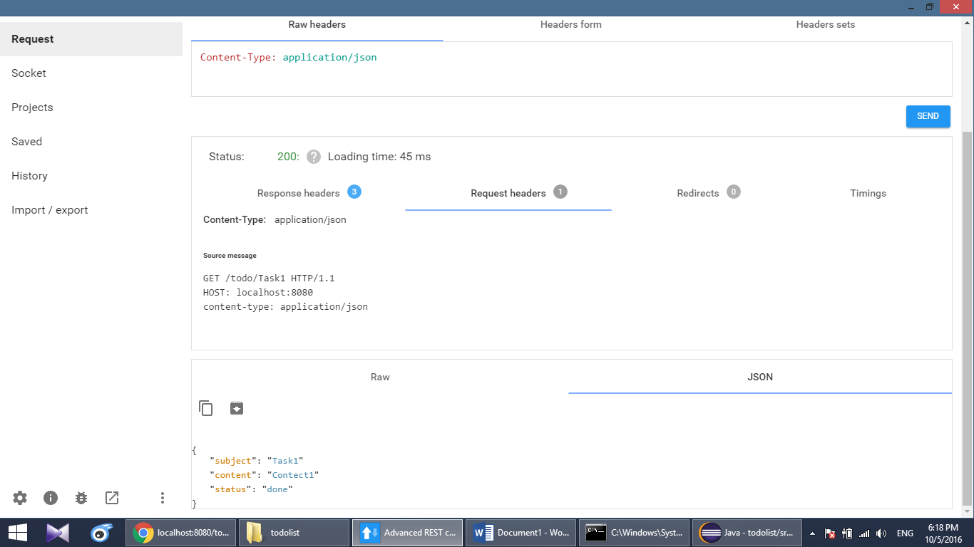

# Add a task

URL:[**http://localhost:8080/todo**](http://localhost:8080/todo)

Add Task5

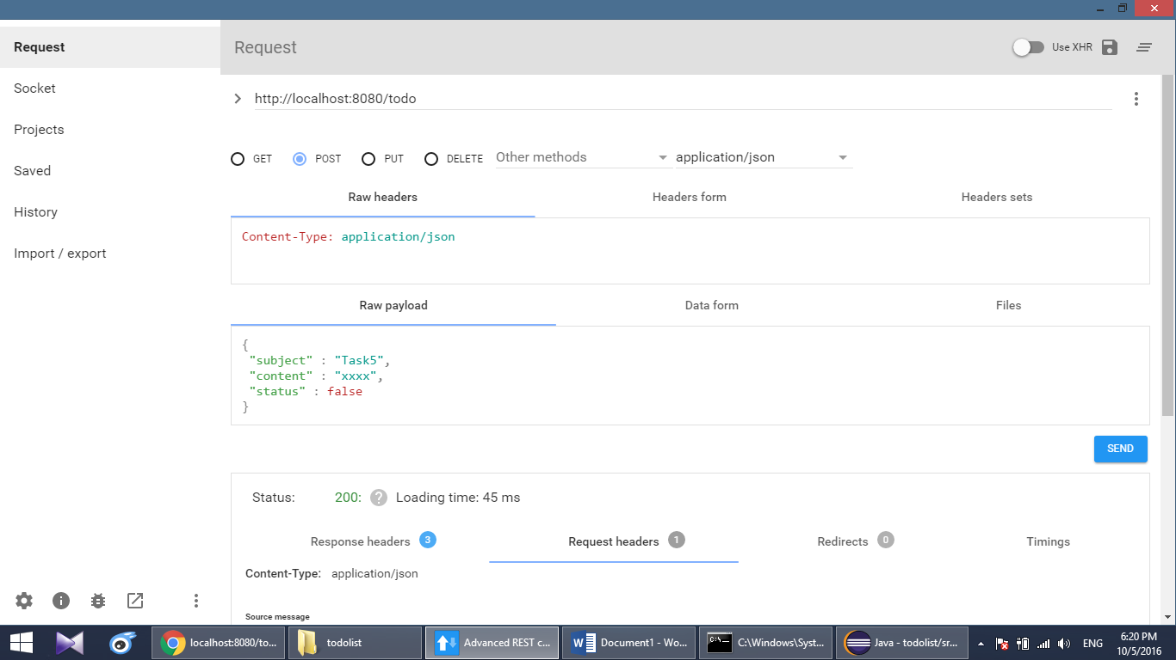

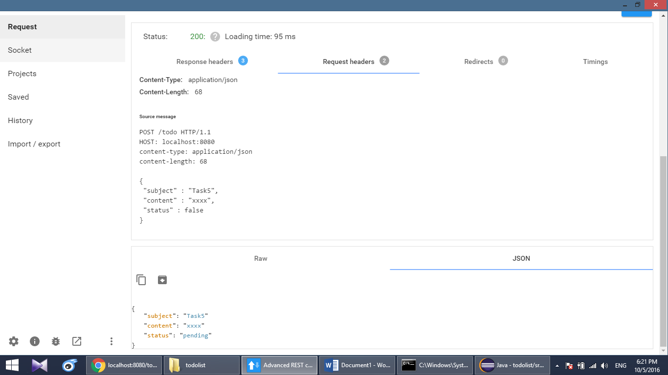

**Check result**

[**http://localhost:8080/todo/Task5**](http://localhost:8080/todo/Task5)

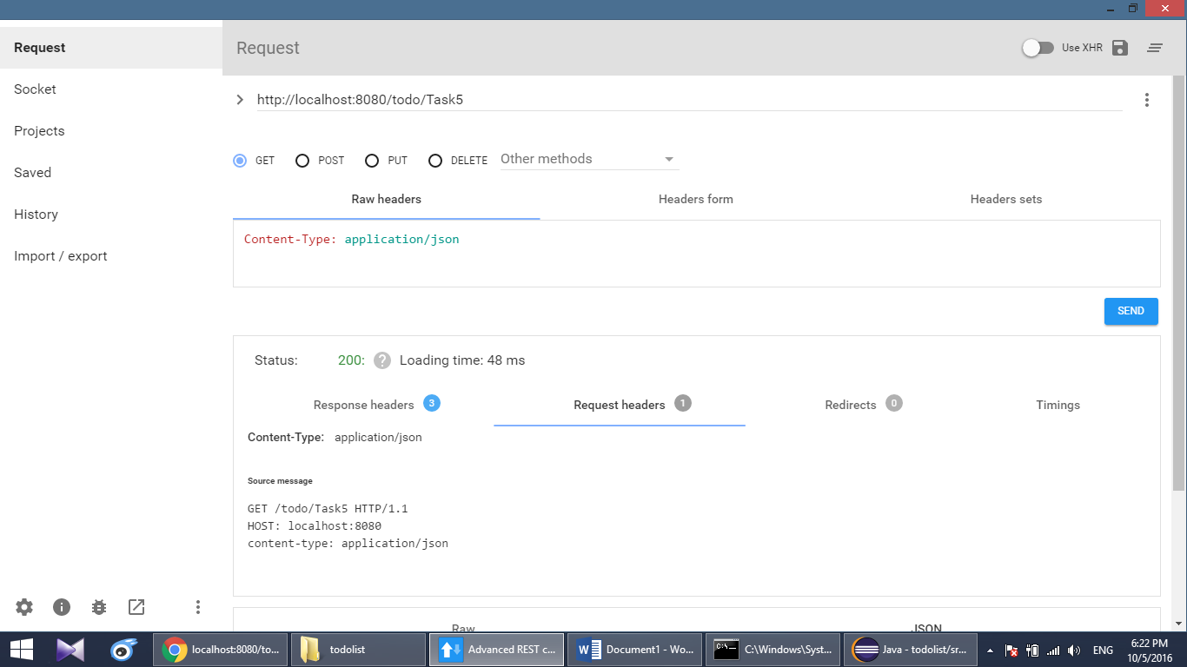

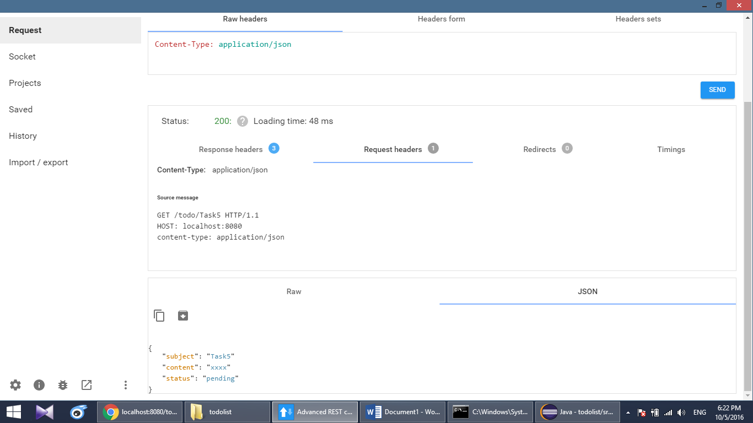

# Edit task

URL:[**http://localhost:8080/todo/edittask?subject=..&contect=..&status**](http://localhost:8080/todo/edittask?subject=..&contect=..&status)**=..**

Edit Task5 set subject = “Task5”, content = “test edit task”, status = true

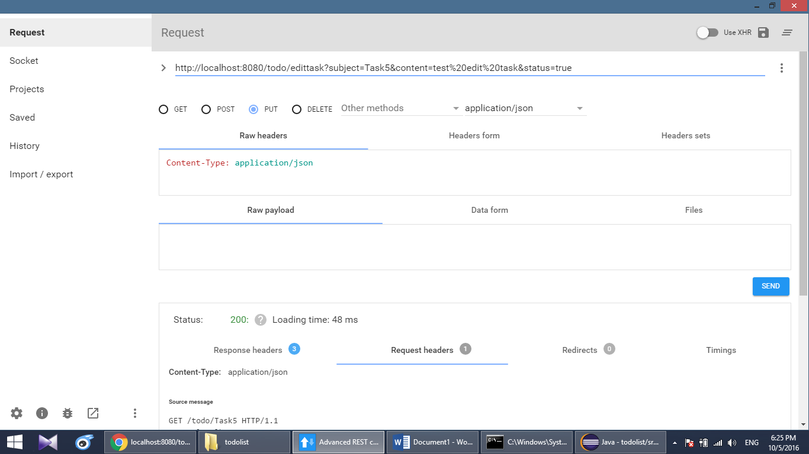

**Result**

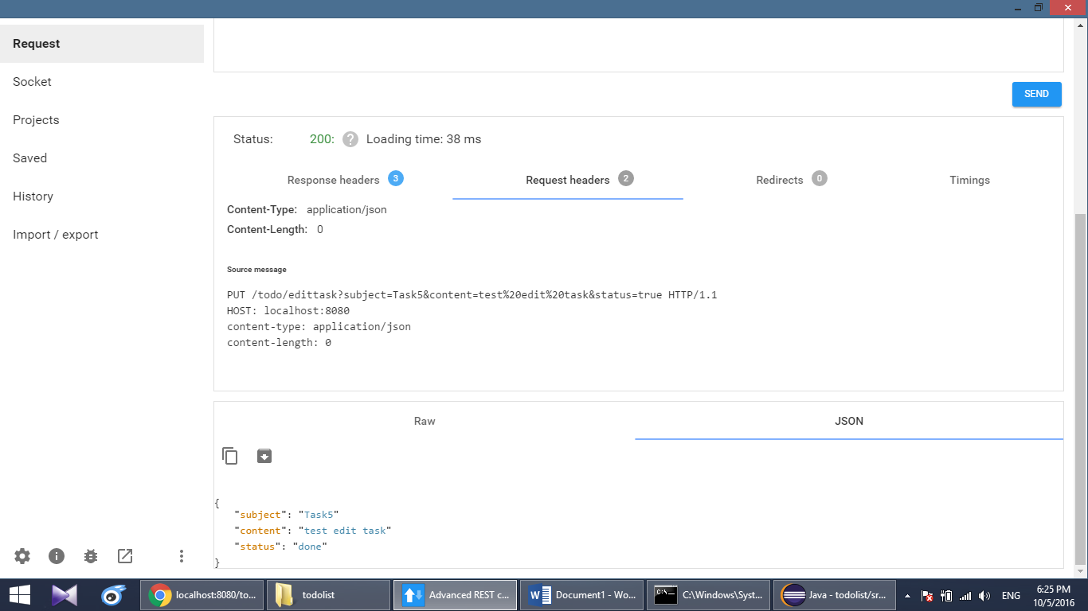

# Set task status

URL:[**http://localhost:8080/todo/setstatus?subject=..&status**](http://localhost:8080/todo/setstatus?subject=..&status)**=..**

Set status Task5 = false

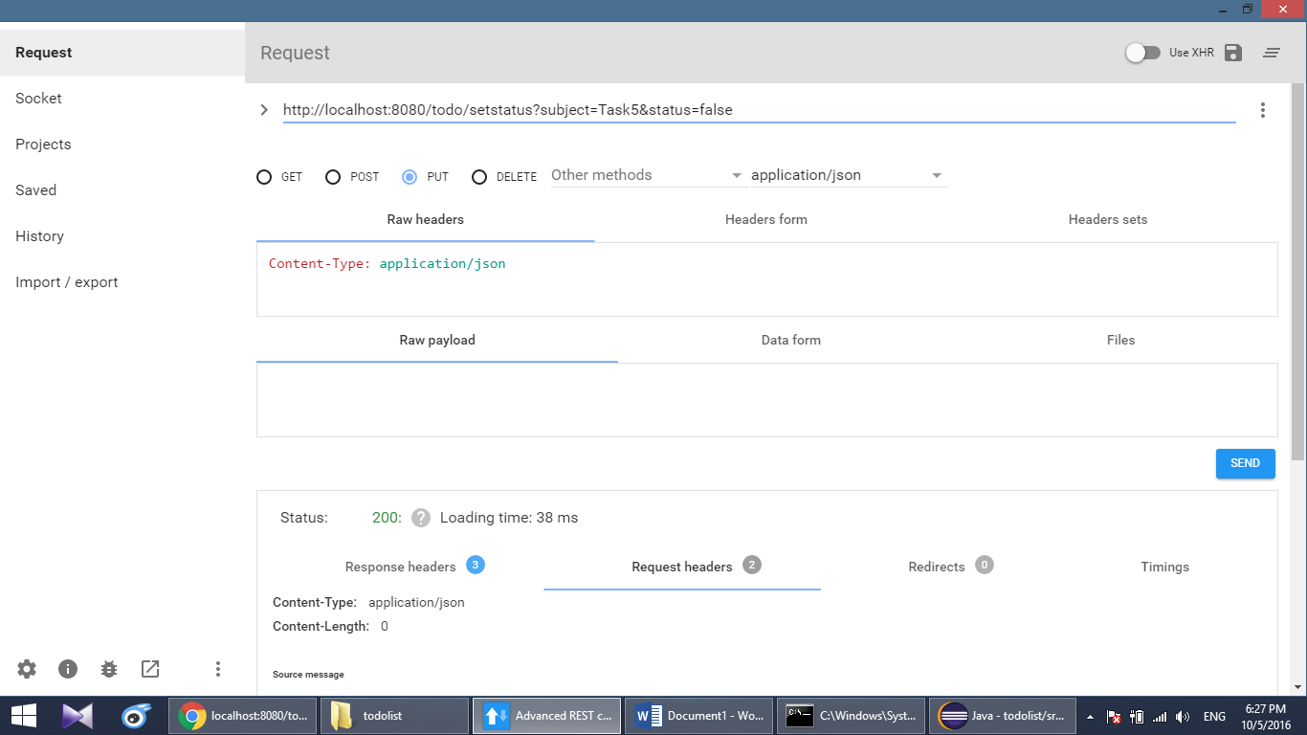

**Result**

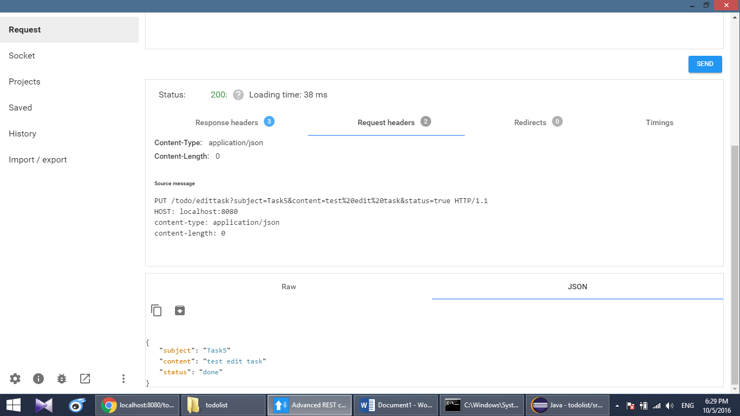

# Delete task

URL:[**http://localhost:8080/todo/{tasksubject}**](http://localhost:8080/todo/%7btasksubject%7d)

Delete Task5

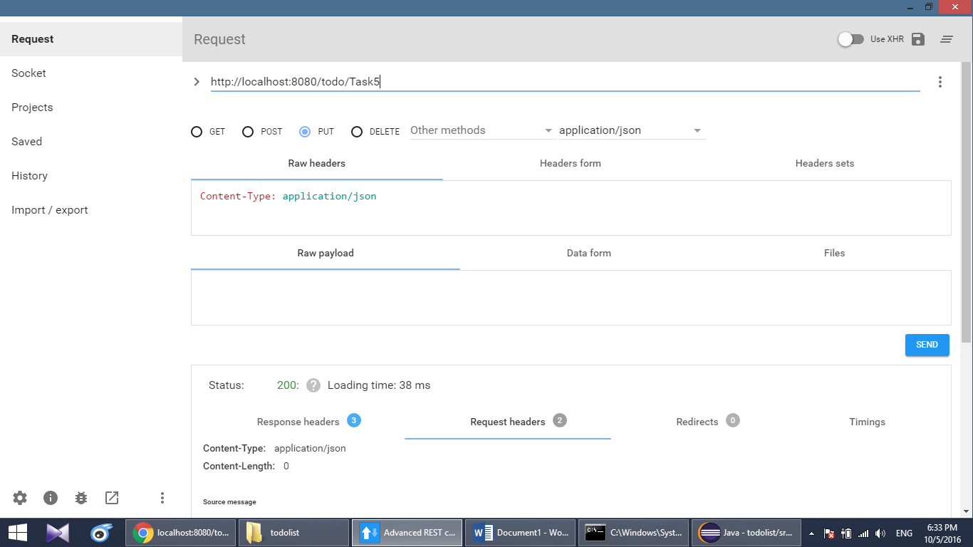

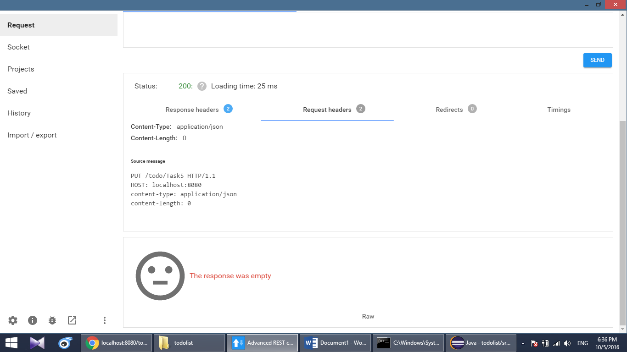

**Check result**

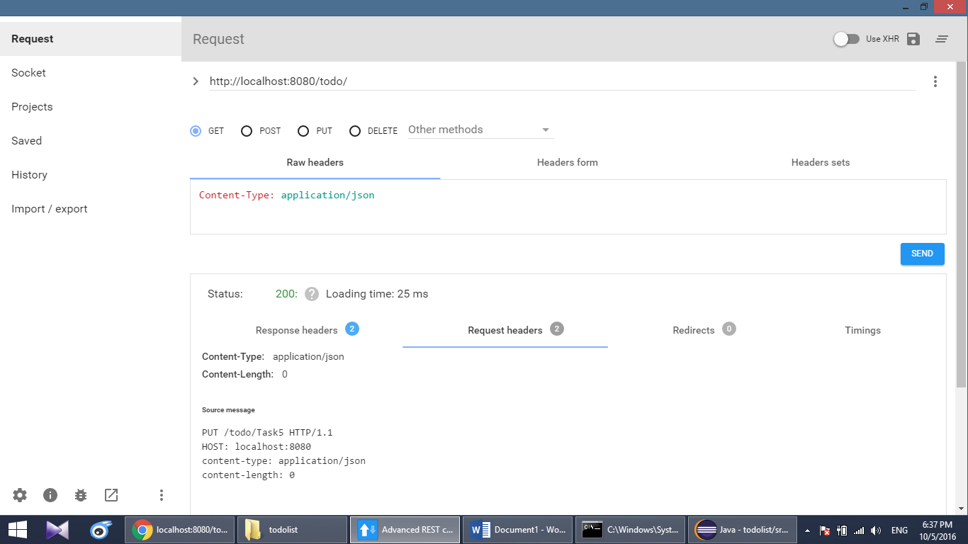

Task5 already deleted

